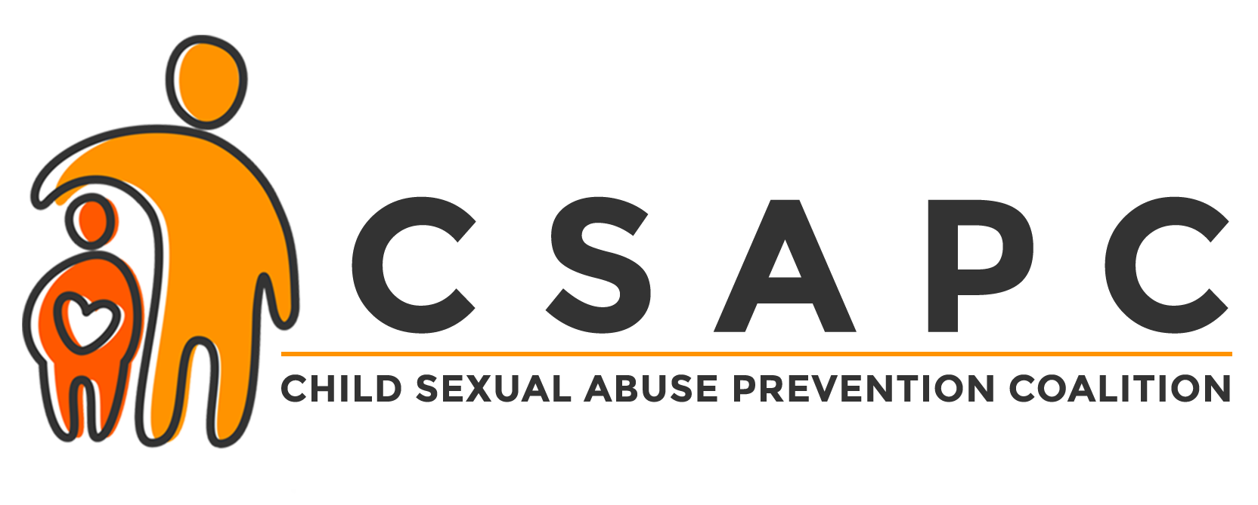

JOIN OUR CAUSE TO PROTECT CHLIDREN
Because 1 in 10 Children Will Be Sexually Abused Before Age 18

OUR MISSION
The mission of the Child Sexual Abuse Prevention Coalition (CSAPC) is to prevent child sexual abuse through the delivery of the Darkness to Light, Stewards of Children® training program to adults in Northeast Florida and to empower an unprecedented preventative action movement with the awareness and knowledge to protect children.

OUR GOAL
In order to make the greatest impact, we need to train 50,000 adults within the next five years with the Darkness to Light (D2L), Stewards of Children, program. D2L is a national nonprofit organization that provides individuals, organizations, and communities with the tools to protect children from sexual abuse. Stewards of Children is a 2-hour prevention program created by D2L, that teaches adults how to prevent, recognize and react responsibly to child sexual abuse (Online and Spanish versions available). The program is designed for use by organizations that serve youth, and for individuals concerned about the safety of children. It is the only nationally distributed, evidence-based program proven to increase knowledge, improve attitudes, and change child protective behaviors.

BECOME A COALITION MEMBER
Join us as a CSAPC member, and be a Partner in Prevention in Northeast Florida! A CSAPC member is an organization or individual who wants to make a difference in their community by educating adults about the protection of children.

Members agree to:
- Advocate for the cause and goal of ending child sex abuse
- Attend a two hour Stewards of Children training or host a training for their organization’s staff and volunteers, led by a CSAPC facilitator (cost is $10/person for workbooks – scholarships for book fees may be available)
- Support the Coalition’s efforts by one or more of the following:
  - Placing the CSAPC logo and online training link on their organization's website
  - Hosting a training for their board members or a general community training
  - Joining a CSAPC committee
  - Providing funding for workbooks or sponsoring a facilitator training

PARTNER WITH US TO PROTECT CHILDREN
Donations for workbooks, facilitator trainings, staffing and supplies are greatly appreciated and will help further our mission of protecting children. Donations can be made online at www.csapc.org and are tax-deductible. You can also help stop this epidemic by spreading awareness of our mission or by becoming a facilitator. For more information contact CSAPC Program Manager, Mercede New, at info@csapc.org or (904) 384-1361 ext. 4257.

THANK YOU CSAPC MEMBERS!
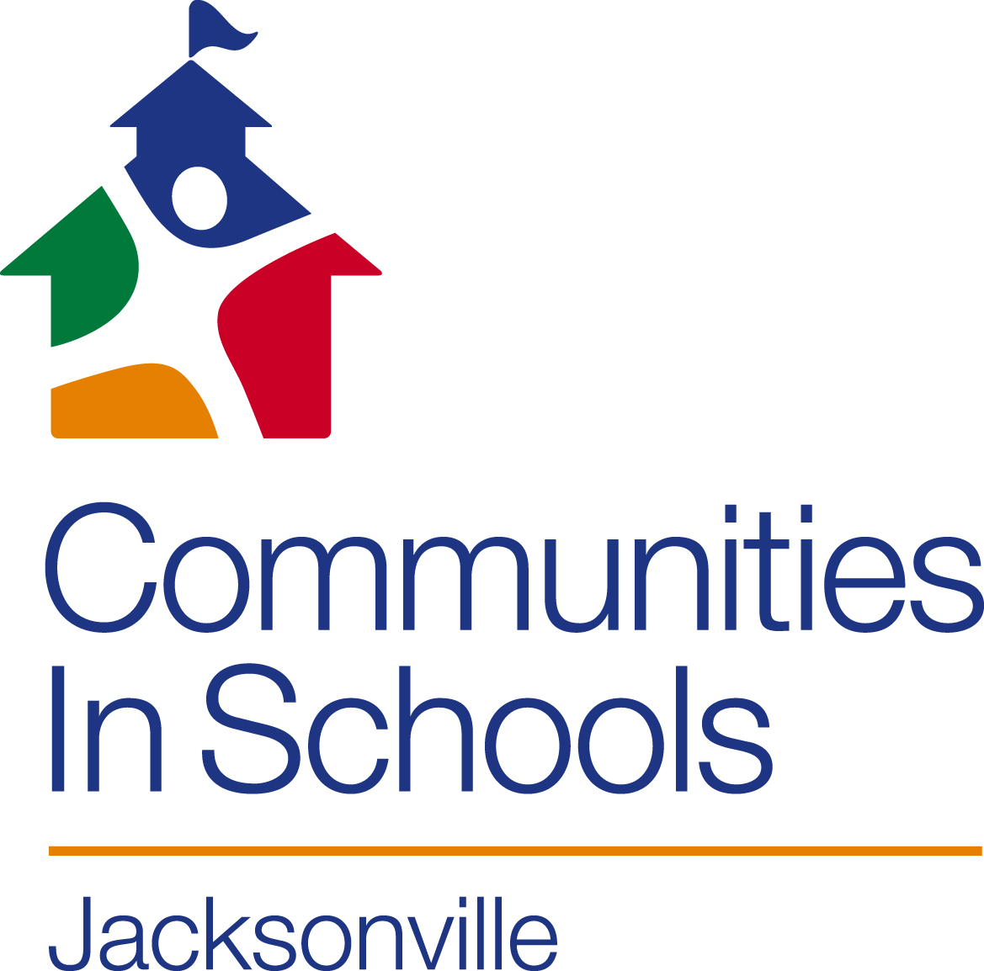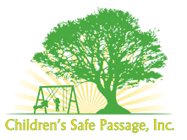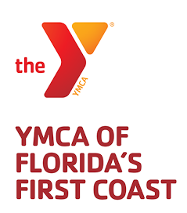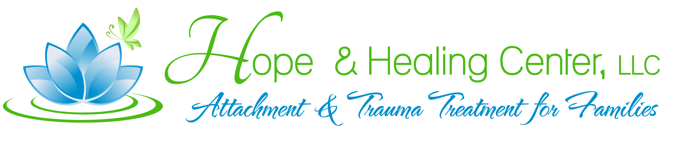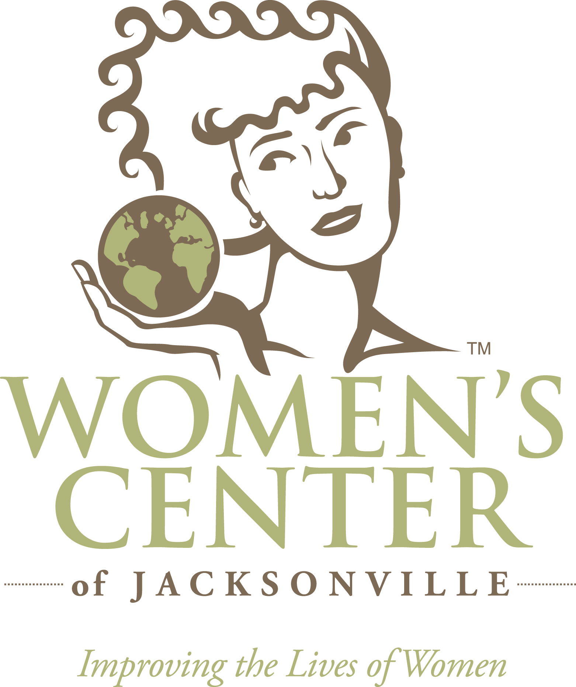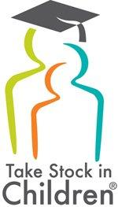
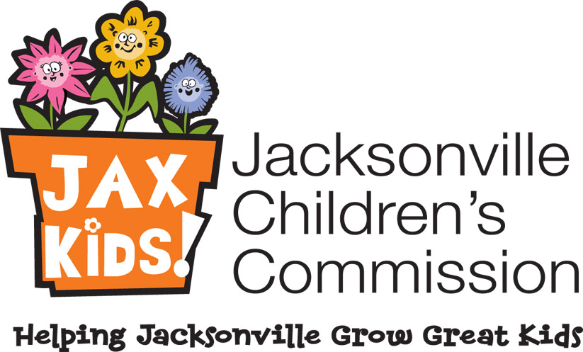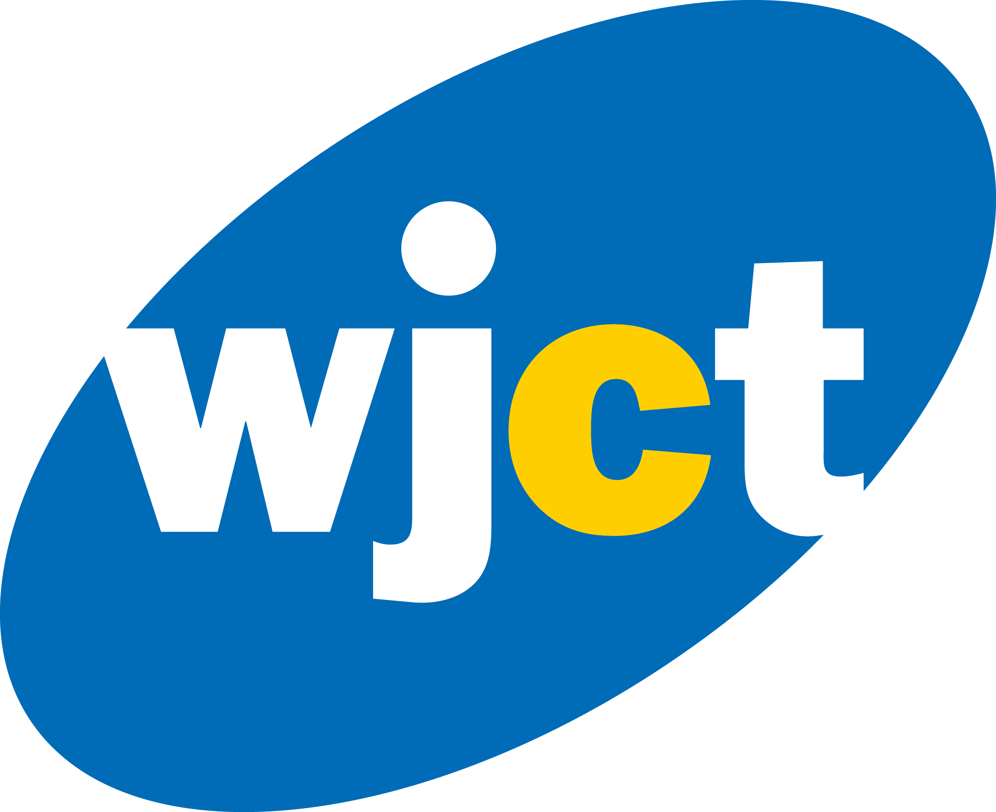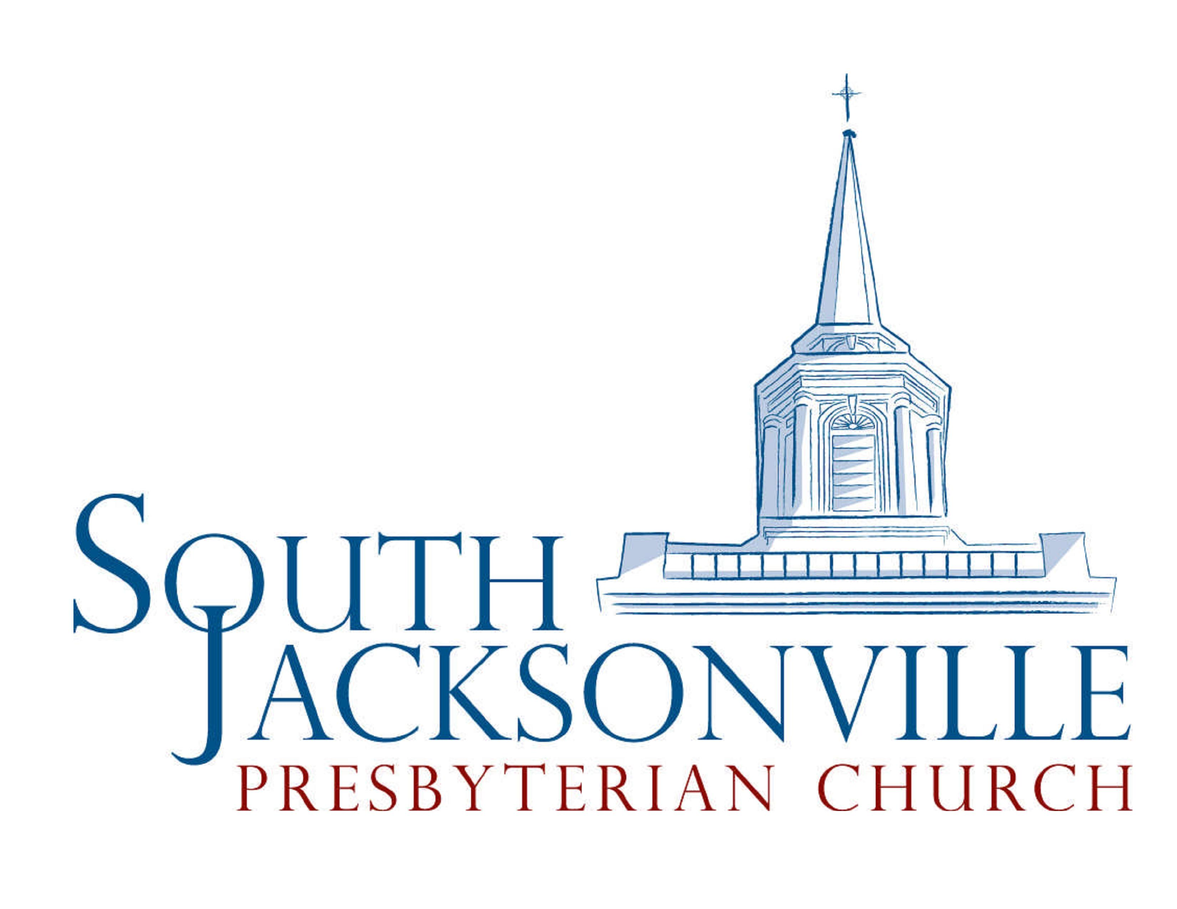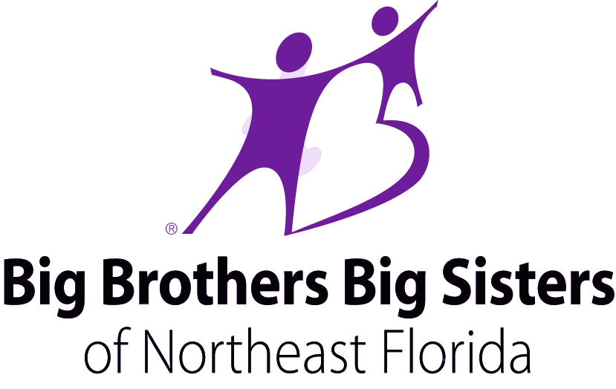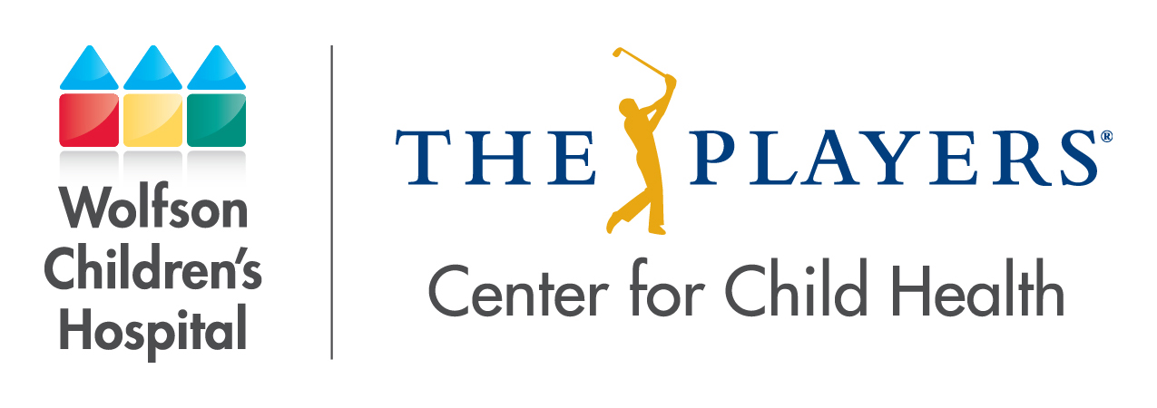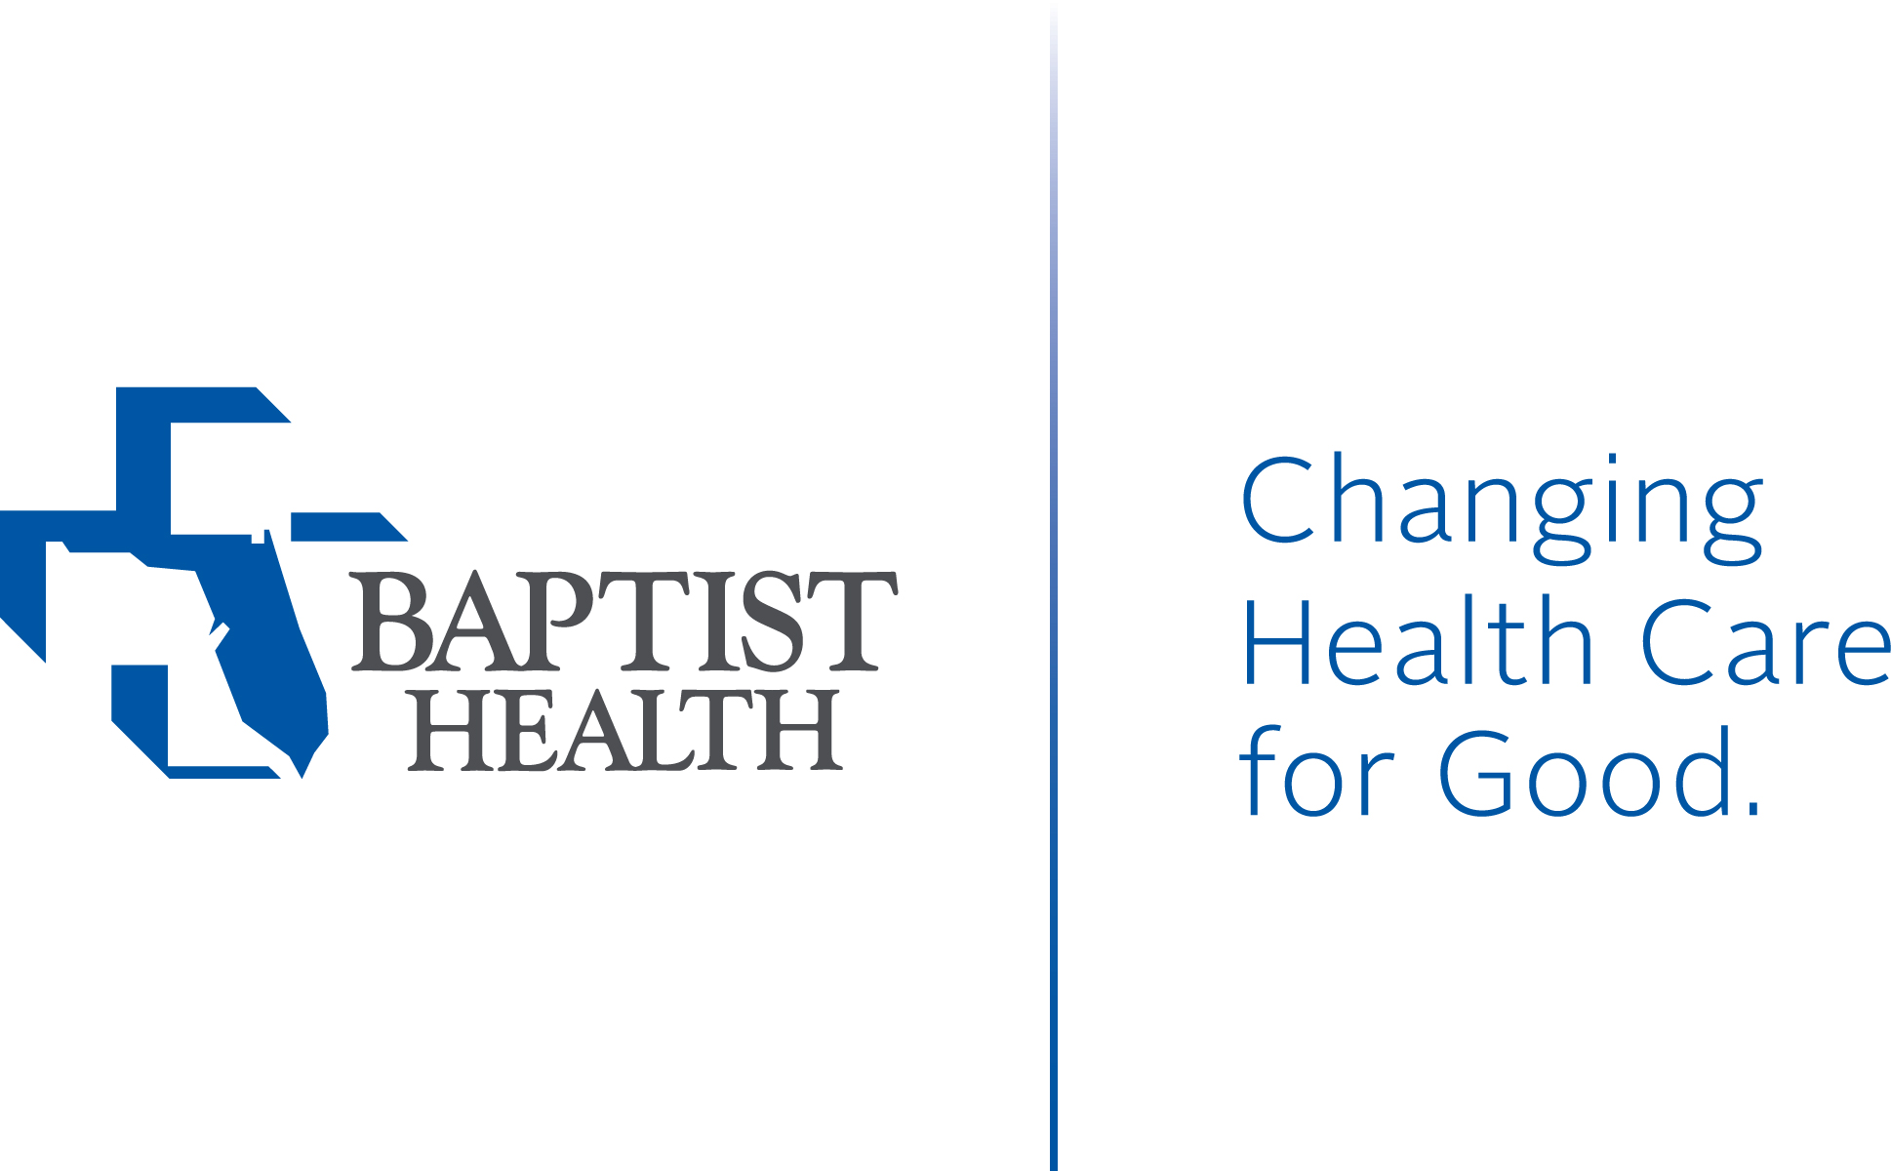

www.csapc.org info@csapc.org

